• Drilling
• Engineering geology
• Hydrogeology
• Geophysics
• Mining
• Construction (civil engineering)
• Ecology

COMPANY PRESENTATION ’19

Company presentation

Company Profile
“Geoing Group” d.o.o. has been successfully working on different exploration projects since 2003. “Geoing Group” d.o.o. offers a comprehensive service including interpretation of the results, reporting and presentation, projects analysis and recommendation for the future studies in the area of:
- Geology (engineering geology, hydrogeology and geophysics);
- Mining;
- Construction (civil engineering)
- Ecology
- Drilling services
Company disposes with the equipment’s and instruments for practicing research on the terrain surface, in the wells, mining spaces and also on the localities of architecture structures.
Our company practices researching from the regional level to detail working in the aim to:
- Finding trestle of metallic and nonmetallic mineral raw materials;
- Solving structural-geological problems;
- Solving hydrogeological problems in the field of water supplying etc.;
- Marking out conditions, ways of foundation and sanitation of structures.

Geoing Group d.o.o. has developed high levels of standardization as follows:
- ISO Standard 14001:2015 (ENVIROMENTAL MANAGEMENT SYSTEM)
- ISO Standard 9001:2015 (QUALITY MANAGEMENT SYSTEM)
- OHSAS 18001 (STANDARD FOR OCCUPATIONAL HEALTH AND SAFETY MANAGEMENT SYSTEMS)
Some of the companies that we worked with successfully:
- RTB BOR
- FACULTY OF MINING AND GEOLOGY , Belgrade
- ELECTRIC POWER INDUSTRY of SRPSKA, SERBIA AND MACEDONIA
- SWISS HUMANITERIAN ORGANIZATION FOR HELPING DIZASTERS (SDR)
- DMT, Essen Germany
  - Dam 3A at Veliki Krivelj tailing pond
- HiSeis, Australia
  - Neves Corvo, Portugal and Republic of Ireland
- IGC, Canada
- Ultra-Balkans, Serbia (Ultra Lithium, Canada)
- Rakita exploration, Serbia
- Kruna Drill, Skopje
- Akita University, Japan
- Turkish Embassy in Belgrade
- Capital drilling
  - Tilva, Serbia
- Sisecam
  - Soda Lukavac, Bosnia and Herzegovina
We have 7 (seven) graduate engineers, over 20 drillers as full-time employees.
We also engage PhD, M.S. and graduate engineers of geology as part-time employees. Above-mentioned personal structure assure very successful solving geological, hydrogeological, engineering geological, etc. problems.
During the processing of field and laboratory research activities are used by software packages AutoCAD, Corel DRAW, Surfer, Grapher, Well Vision, Geo slope 5, in order to achieve the highest level of technical processing.

DRILLING services

Drilling Methods
- Surface Wireline Core Drilling
- Underground Wireline Core Drilling
- Reverse Circulation Drilling
- Multipurpose Drilling
- Directional Drilling
- Environmental & Geotechnical Drilling
- R.A.B. (Rotary Air Blast) Drilling
- Water Well Drilling

Drilling Systems
- Wireline Core Sizes
- Tri-Cone Sizes
- Hammer Sizes

Survey / Down the hole equipment
- Leica system
- Deviflex non-magnetic surveying system
- Core Orientation
- Auslog borehole logging tools (standard operation)

Drilling is performed with the following rigs
Our rigs are a flexible and can undertake different drilling tasks.
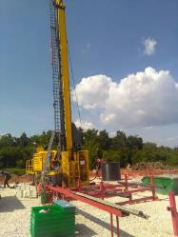 | CHRISTENSEN CT-20C  Manufacturer: Atlas Copco  Serial #: TMG17SEDO131  Year of production#: 2017  Drilling mode: wireline  Depth Capacity:  NQ / 75,7 mm : 2450 m  HQ / 96,0 mm : 1600 m  PQ / 112,6 mm : 1055 m
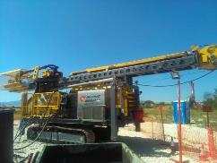 | CHRISTENSEN CT-20C  Manufacturer: Atlas Copco  Serial #: TMG16SEDO337  Year of production#: 2016  Drilling mode: wireline  Depth Capacity:  NQ / 75,7 mm : 2450 m  HQ / 96,0 mm : 1600 m  PQ / 112,6 mm : 1055 m
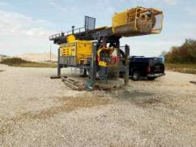 | CHRISTENSEN CT-20  Manufacturer: Atlas Copco  Serial #: TMG16SEDO219  Year of production#: 2016  Drilling mode: wireline  Depth Capacity:  NQ / 75,7 mm : 2450 m  HQ / 96,0 mm : 1600 m  PQ / 112,6 mm : 1055 m
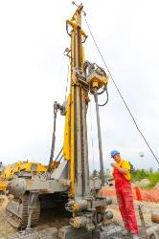 | MUSTANG 13F1 HD  Manufacturer: Atlas Copco  Serial #: 8993067026  Year of production#: 2013  Drilling mode: wireline, conventional, DTH drilling  Depth Capacity:  NQ / 75,7 mm : 1600 m  HQ / 96,0 mm : 1200 m  PQ / 112,6 mm : 850 m
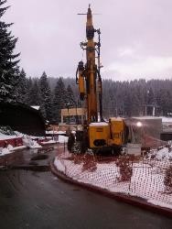 | MUSTANG 13F1  Manufacturer: Atlas Copco  Serial #: 8993067034  Year of production#: 2013  Drilling mode: wireline, conventional, DTH drilling  Depth Capacity:  NQ / 75,7 mm : 1200 m  HQ / 96,0 mm : 800 m  PQ / 112,6 mm : 600 m
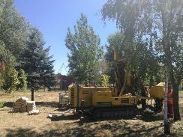 | MUSTANG 4F1  Manufacturer: Atlas Copco  Serial #: OR.09.6990060233.510  Year of production#: 2007.  Drilling mode: wireline, conventional, DTH drilling  Depth Capacity:  75,7 mm to 150 mm, up to 250 m
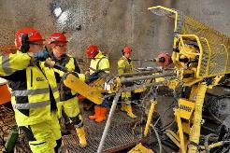 | DIAMEC PHC 6  Manufacturer: EPIROC  Serial #: TMD 18SED0532  Year of production#: 2018.  Drilling mode: wireline  Depth Capacity: vertical up/down  AO / 48 mm 985/1445 m  BO / 60 mm 600/1065 m  NO / 75,6 mm : 340/715 m  HO / 96,1 mm : 155/335 m
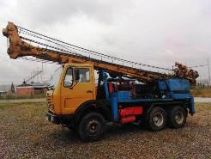 | B2A-NR30  Manufacturer: WIRTH  Serial #: 71.794.00-99  Year of production#: 1984.  Drilling mode: RC

Our rigs are a flexible and can undertake different drilling tasks.

- Off road vehicle, Toyota Hilux 4WD Double cab | 3
- Off road vehicle, Nissan Navarra 4WD Double cab | 2
- Off road vehicle, Dacia Duster 4WD | 1
- Fap-Mercedes 7 t | 1
- Mercedes Sprinter 1t | 1
- Mercedes (water tank ) – 8 m³ | 1
- TAM 5000 (water tank) – 3 m³ | 1

take 5 – personal risk assessment
GEOING GROUP adopts the TAKE 5 personal risk assessment program and begins each shift with a "Take 5 for Safety" meeting. The schedule and scope of work anticipated for the day is carefully outlined, hazards inherent to these activities are itemized and discussed. The five steps listed below is the daily topic for the meetings, each step is discussed thoroughly to ensure everybody has a safe and productive shift.

Step 1 - Think through the task
The first step to identifying and controlling the risk we face in a task is to think through all the steps in your task.

Step 2 - Look for the Exposure
The second step is to look for the risk, think about all the steps and ask yourself “What If”.

Step 3 - Assess the risk
What is the likelihood of a problem? What are the consequences of a problem?

Step 4 - Remove the risk
Eliminate it, Substitute it, Apply safety Controls, Apply Engineering Solutions, Protect people, environment, equipment.

Step 5 - Do the job safely.
Monitor your plan for effectiveness, watch for changing conditions if things change go back to step one and start the process over.

Environment
GEOING GROUP is committed to:
- Protection of the environment.
- Complying with environmental regulations and to respect archeological and cultural sites.
- Maintaining equipment, premises and drill sites in environmentally sound condition.
- Ensuring that acceptable and industry standards are practiced by all employees.
In fulfilling our commitment to protect the environment, we promote:
- Assessment of the effect of work on the environment and integrate protective measures into the planning process to prevent or minimize the impact on natural resources.
- Preservation of environmental integrity by complying with applicable Acts and Regulations.
- Application of technologically advanced environmental protection methods.
- Restoration of drill and camp locations to acceptable environmental conditions on termination of project
5
MACEDONIA
GEOING GROUP DOOEL
1596 Street, 28/1-38 Gorce Petrov,
Skopje 1000,
Republic of Macedonia
BOSNIA&HERZEGOVINA
GEOING GROUP B
Mese Selimovica Street, 4,
Bijeljina 76300,
Republic of Srpska
Bosnia and Herzegovina
SERBIA
GEOING GROUP DOO
Kraljice Marije Street, 25,
Belgrade 11000,
Republic of Serbia

www.geoing.rs

geoing.group@gmail.com

